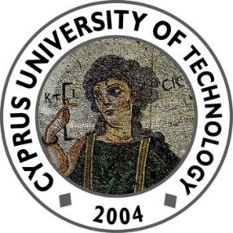


  - Computer Engineering & Informatics

  - English for Computer & Informatic Engineers I (LCE 115.3)

Article Summary: “Emerging Technologies and their Impact”

Author: Supervisor:
Georgios Karyos Dimitrios Boglou
(Student Number: 30738)

September 30, 2024

The article entitled «5 Technologies That Will Change the Future of The Human Race» by Bernard Marr, highlights the major emerging technologies that are expected to change industries, transform society and improve human potential. These technologies include: None other than Artificial Intelligence, which has affected the world with it’s extraordinary ability to learn and adapt over time, implementable in almost every aspect of human life. Following that, the author discusses Gene Technology, which involves the power of understanding, manipulating and editing DNA, which raises serious concerns. Furthermore, the writer addresses Human-Computer Interfaces, explaining how technology could co-exist with the human body, evolving us to something many refer to as “superhumans”. Moreover, we are introduced to Extended Reality, a tool that benefits education and virtual exploring but poses costs for humans. Lastly, 3D Printing could revolutionize manufacturing by creating products on demand but also enables weapon creation. These technologies offer great potential but raise significant ethical challenges.

